Enclosure ratings
 | UV stable thermoplastics
 | Mounting | 35mm DIN rail, wall mount and pole-top mount
 | Dimensions | 337.75 x 160 mm
 | Terminals | 2 x 25mm² and 2 x 16mm²
 |  | With 960º glow wire resistant end blocks
Typical configurations: BEC44(09) / wBEC44(09)
Description: Two meters and two breakers (63 A only)  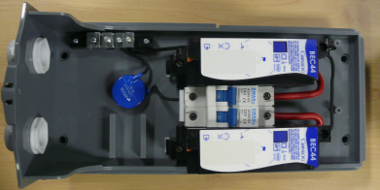 |  | Description: Two meters only  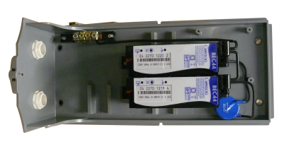
Description: One meter and one (63/80 A) breaker  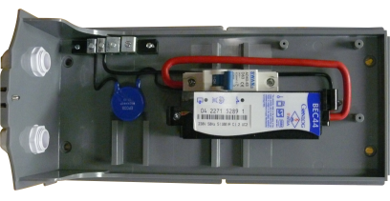 |  | Description: One meter only  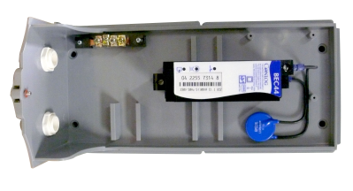
Enclosure only
Contents:
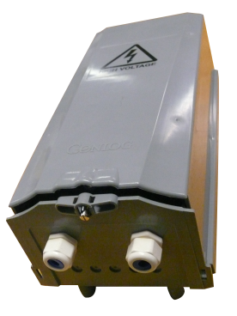
  - Front cover
  - Rear cover
  - 2 x cable glands
  - Neutral busbar with cage clamps

